BIODATA

Name:Kolhe Vivek Namdevrao  Adress: Kumar Sahawas, B-203, Plot No.1, S.No 132/2, Near Ojas apt, Baner-Pashan link road, Pashan. Pune 411021 | 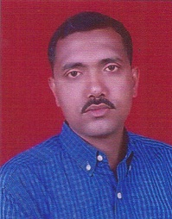

Designation: Assistant Professor

Educational Qualification: M.Sc. (Physics)

Teaching Experience: 15 years

Classes Taught:F.Y.,S.Y.,T.Y.B.Sc.,M.Sc.I & II Year
Faculty development programmes (Orientation/ Refresher/ Short term courses): one refresher course

orientation programme: Nil

Research Area: Nil

Research Projects:Nil

Research Articles published In Journals: Nil

Paper presented in International Conference: Nil

Paper presented in National/ State/ University level Conference: Nil

Awards/Honours:Nil

Books Published:Nil

Innovations in Curriculum design and transactions: Nil

Resource Person: Nil

Seminars/Workshops/ Training courses attended:
International conference on Life Science & Earth science organised by Ramkrishna More college Akurdi
Participation in community/ Social Services: Nil

Memberships on various bodies: Chairman Life long learning and extension department

Computer Skills: ADCSSAA

